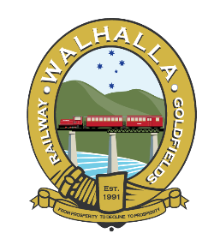
WGR Order form for Dog Spike Whistles and Fire Pit
A unique gift. Whistles made from old WGR Dog Spikes $15.00 each, Fire pit $175.00 is made from old WGR Dog Spikes and fish plates no longer of use for the track.
Free delivery to buyers in the Latrobe Valley, all other orders will need to be picked up from WGR when we re-open.
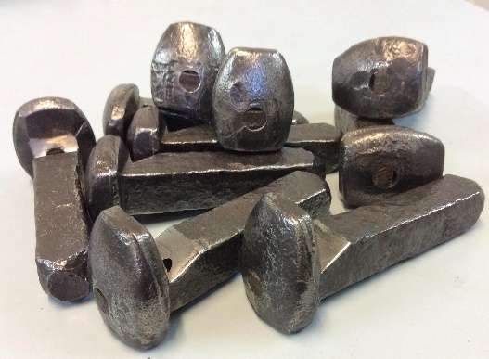
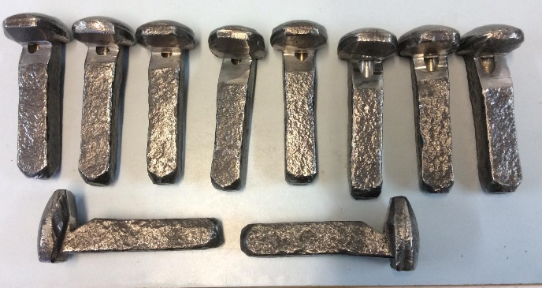

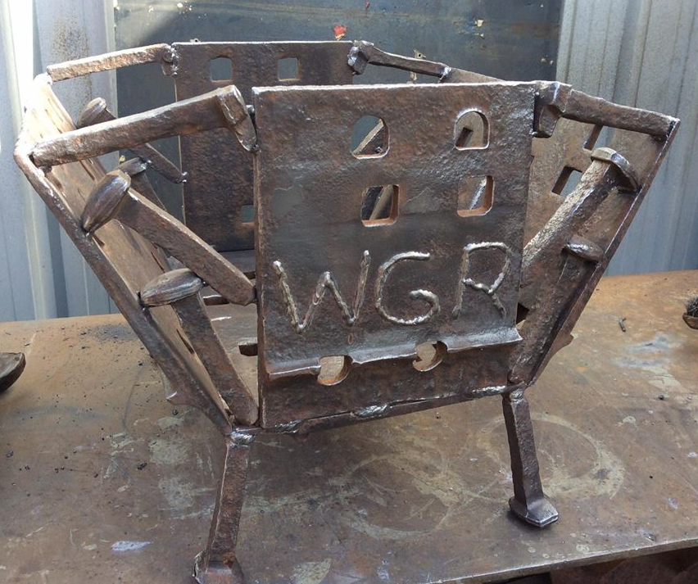
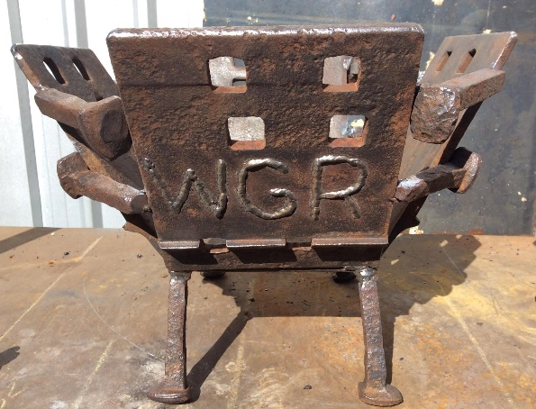

Name ………………………………..
Address (only for Latrobe Valley) ……………………………………………
………………………………………………………………………
Phone………………………..
Card details _ _ _ _ _ _ _ _ _ _ _ _ _ _ _ _ Expiry _ _ _ _

Qty ___ Fire Pit $175.00 total $……..
Qty ___ Whistle $15.00 total $……..
Grand Total $……..

