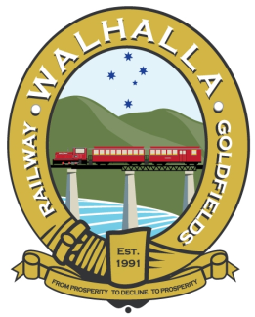

WALHALLA GOLDFIELDS RAILWAY

NIGHT TRAIN FREQENTLY ASKED QUESTIONS

WHEN DO I ARRIVE?
We normally recommend you arrive no later than 30 minutes prior to your selected departure time to ensure smooth operation eg: No later than 5:30 for the 6pm & 7:30 for the 8pm
WHERE DO I PARK?
There is limited parking in the station courtyard, however more parking is available at the in the public car park on the right side of the road towards the township.
IS IT COLD?
The short answer is yes, so it’s advisable that you dress for a cold night!
WHAT IF IT’S RAINING?
The night train will continue to run as carriages are enclosed with closeable windows.
ARE THE WINDOWS OPEN?
Normally yes to provide a good view, so dress for a cold night
WHAT’S THE FARE?
Adult $45, Concession $40, Child $40, Family $130.
WHO CAN BUY A FAMILY TICKET?
Groups of 2 adults & 2 Children OR 1 adult & 3 children.
IS THERE ANYTHING TO EAT?
Hot food to be served in our historic goods shed.
Make sure to arrive early if you’re planning to eat!
Please contact wgrmarketing66@gmail.com or call 03 5165 6280 for further info.
WHAT ELSE IS OPEN?
Walhalla’s famous ghost tour also operates on the first three Saturdays of every month. Please see www.facebook.com/walhallaghosttours/ for more info.
HOW LONG DOES IT TAKE?
The return trip to Thomson station along the picturesque Stringer’s Gorge is around 1 hour.
DO YOU TAKE GROUPS?
Yes we do! Please contact office@walhallarail.com.au or wgrmarketing66@gmail.com or call 03 5165 6280 for further information on group bookings.

